Setting Up Of Environment

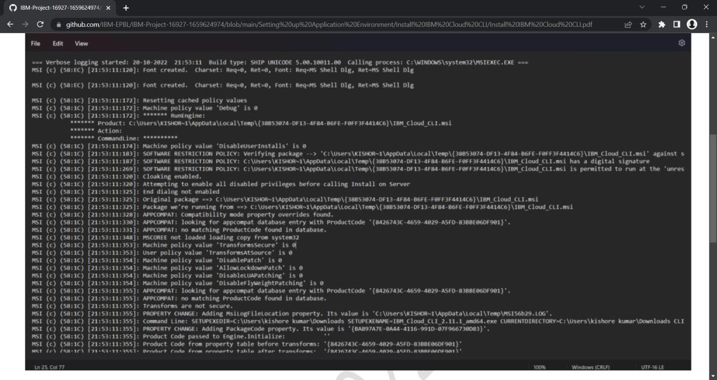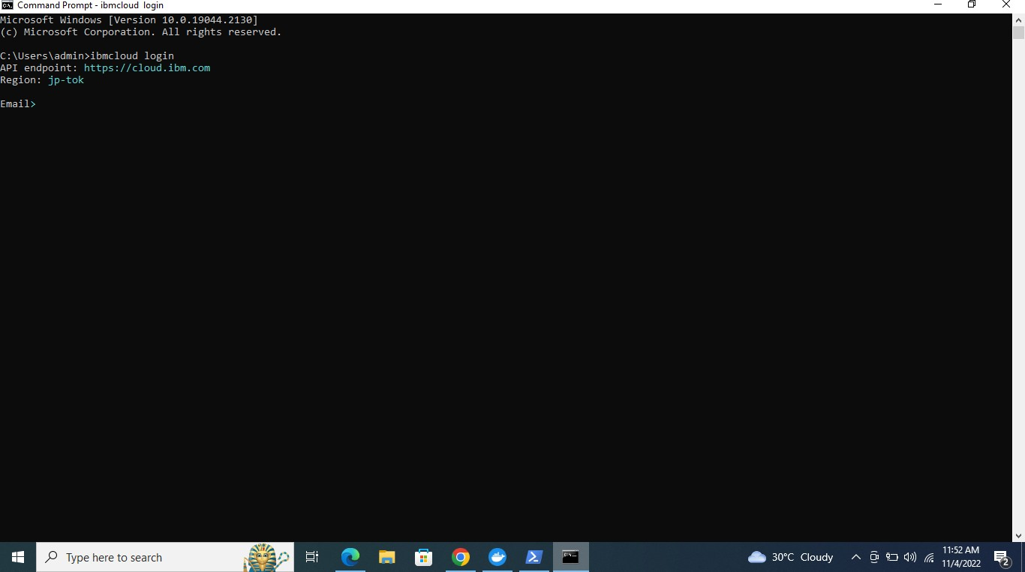

Cloud CLI Installation

TEAM ID: PNT2022TMID39742